**What are the various Dashboards in Bot Central?**

* Bot Health Report- Provides real-time status of bots such as:
  + Total Bots Running
  + In Progress
  + Completed
  + Failed
  + Weekly Bot Status
* Bot Device analytics- Provides real-time status of devices/machines executing bots such as
  + No of bot schedules on devices
  + Device utilization

**Can the RPA tool be used for transferring files from one host/machine to another machine using FTP or SFTP?**

* The FTP/SFTP command in RPA can automate the following:
  + File uploads and downloads from one location to another
  + Secure FTP for secure remote file transfer

**Can the RPA tool integrate with legacy Mainframe/Terminal applications and how does it work?**

* Enables RPA bot to
  + Connect to a Terminal.
  + Set Control Keys
  + Set Text
  + Get text.
  + Move Cursor
  + Close Terminal
* A bot can interact with Green screens, AS400 screens of mainframe application screens to read, write, navigate and move within the terminal screens.

**Provide the architecture overview of the RPA product, list down all the components.**

* **Bot Designer/Creator-** Provides the ability to design, develop, test and debug bots. Provides the ability to visually build Bot models (building blocks) with drag and drop feature using low code visual editor to build the bot flows.
* **Bot Central/Controller/Orchestrator-** Provides the ability to orchestrate, schedule, and manage the deployment of attended and unattended bots. It provides centralized management, centralized access control and collaboration, and centralized workforce management.
* **Bot Runtime –** This is a runtime client that provides the ability to execute the automation/ bots. These are run-time components either deployed on User’s Desktop PCs or on virtual machines where the bot automation can be executed.

### Provide Vertical/Domain Specific use cases of RPA.

* [Banking](https://www.mygreatlearning.com/academy/learn-for-free/courses/case-studies-from-banking-and-finance-industry/?gl_blog_id=34137)– Front office and Back-office operations, customer account management, financial claims processing, Loan updating and processing.
* [HealthCare](https://www.mygreatlearning.com/academy/learn-for-free/courses/healthcare-management/?gl_blog_id=34137)– Bill processing, patient data processing and patient record storage
* [Manufacturing](https://www.mygreatlearning.com/academy/learn-for-free/courses/time-series-in-manufacturing-industry/?gl_blog_id=34137)– Automation of logistics data, data monitoring, and product pricing comparisons
* [Retail](https://www.mygreatlearning.com/academy/learn-for-free/courses/marketing-and-retail-analytics/?gl_blog_id=34137)– Product data extraction, online inventory updating, updating vendor details.
* [Insurance](https://www.mygreatlearning.com/academy/learn-for-free/courses/analytics-in-insurance/?gl_blog_id=34137)– Claims management- automate the administrative activities.
* [Finance and Accounting](https://www.mygreatlearning.com/academy/learn-for-free/courses/financial-accounting/?gl_blog_id=34137)– Reconciliation, Order Entry and updating

**Develop a detailed implementation plan**

For a project like RPA that has implications across departments, following the best practices for implementing it is a no-brainer. Everything from managing and configuring software and hardware should follow the right process. Choosing the right RPA tools, supporting technologies, and the right vendor will go a long way in making the project a success.

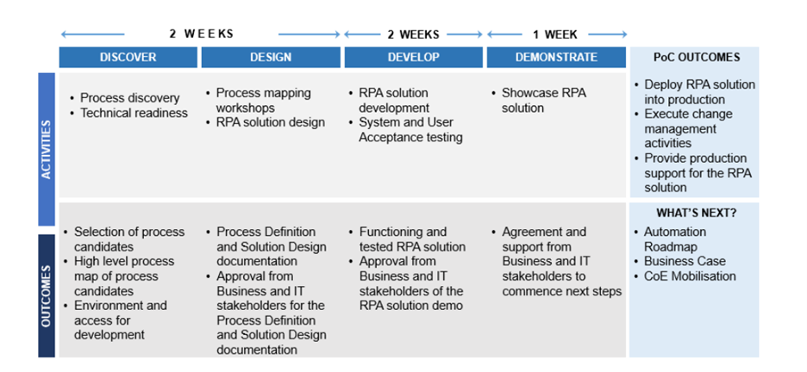

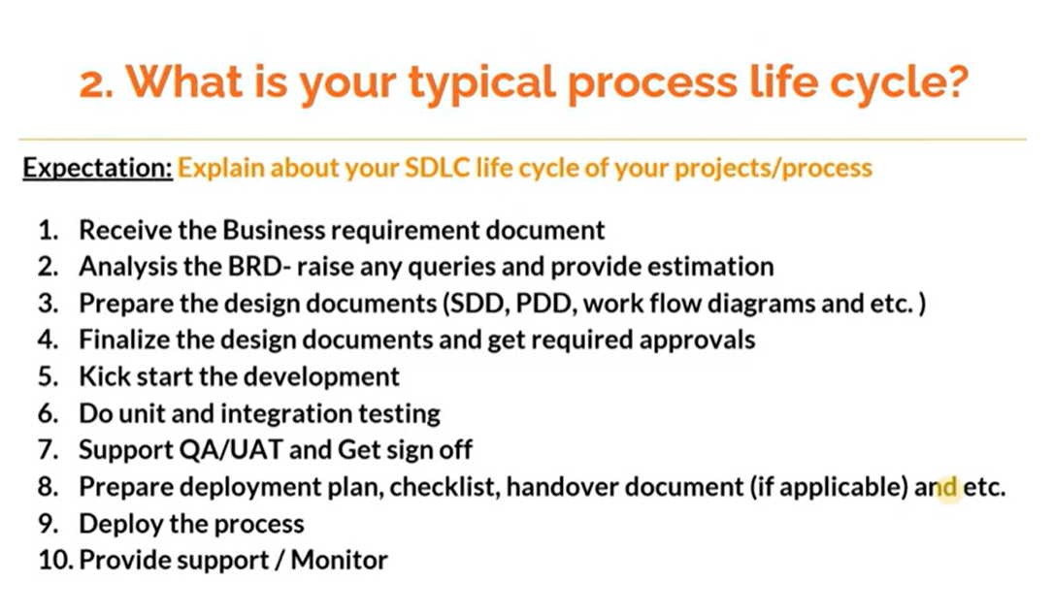

# What is RPA Production & Support Phase? What is Hypercare Phase? Who are involved & the lifecycle?

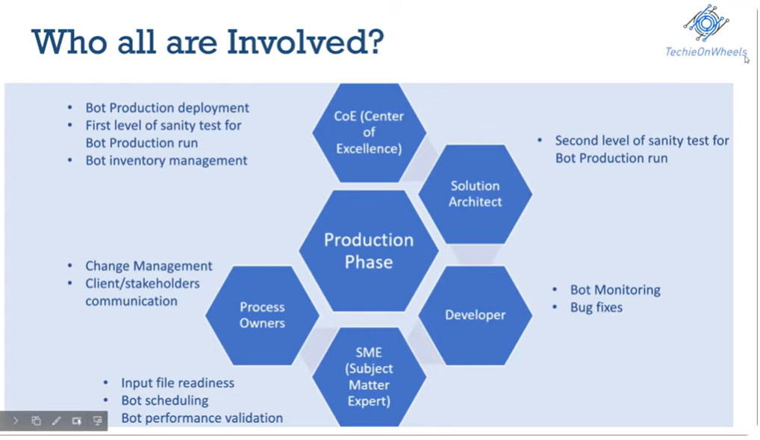

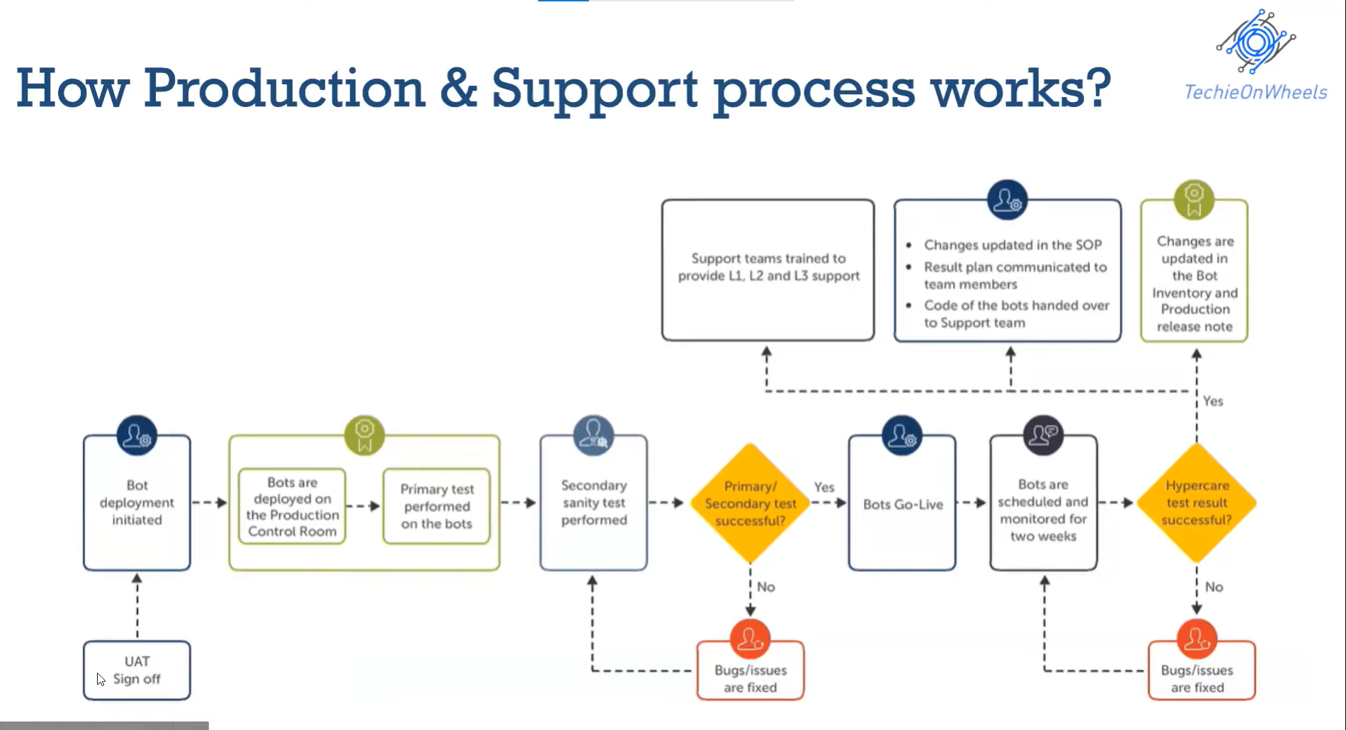

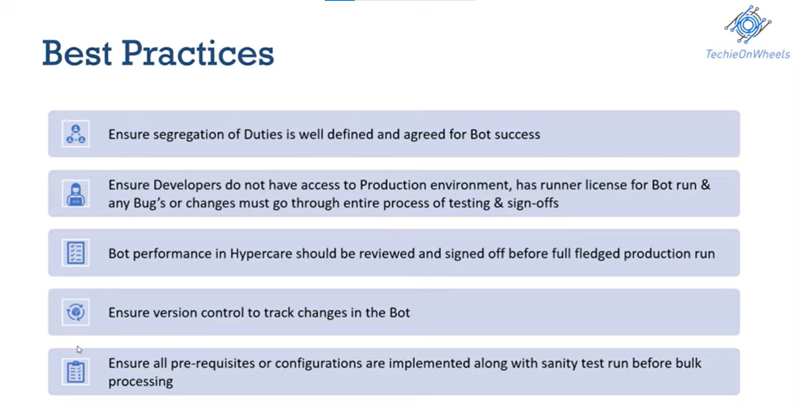

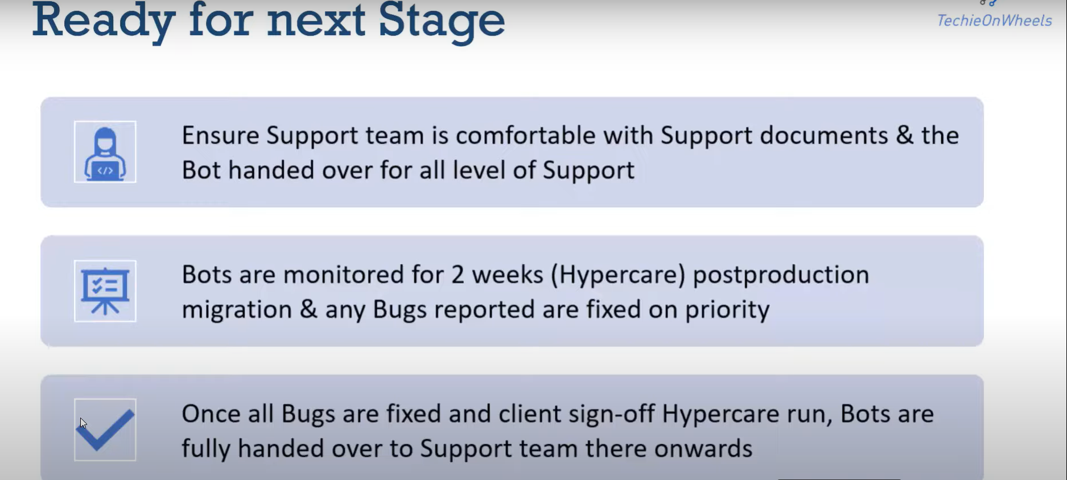

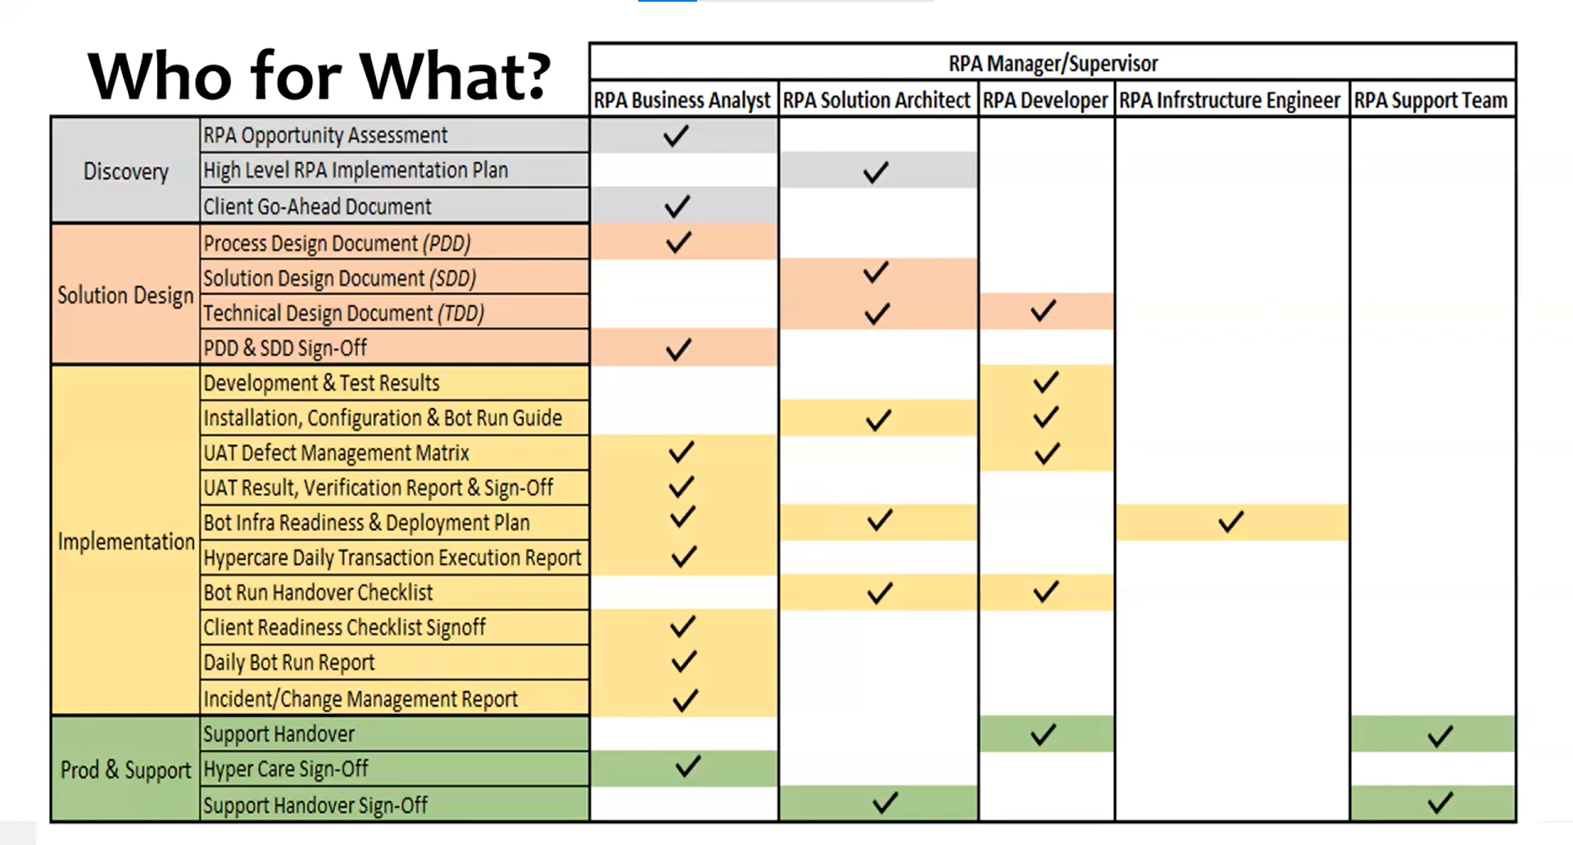

Type of Automation:

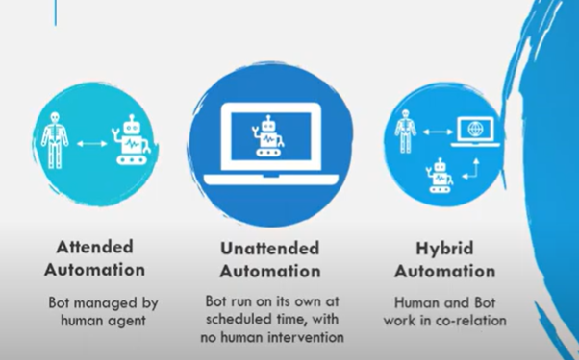

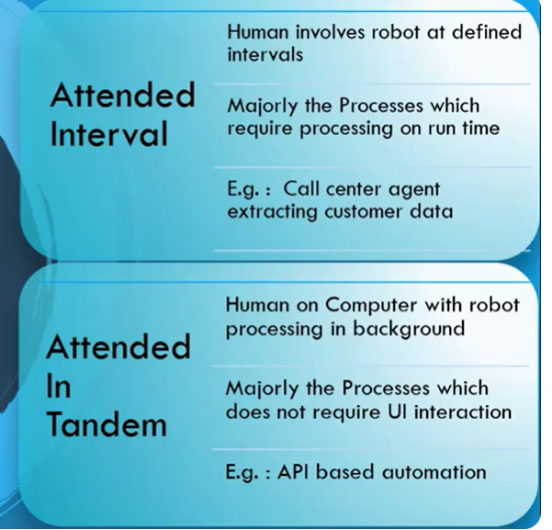

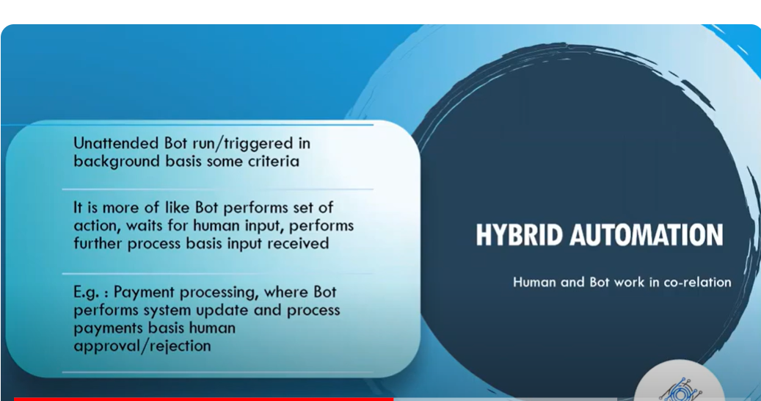

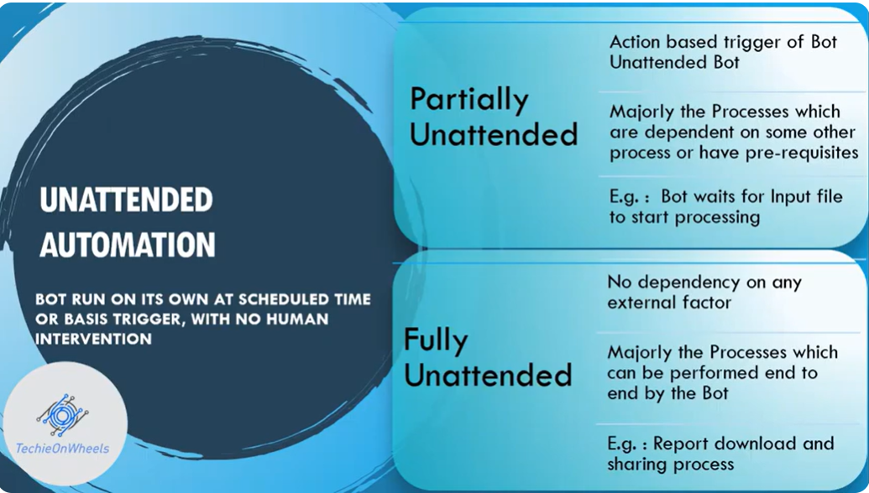

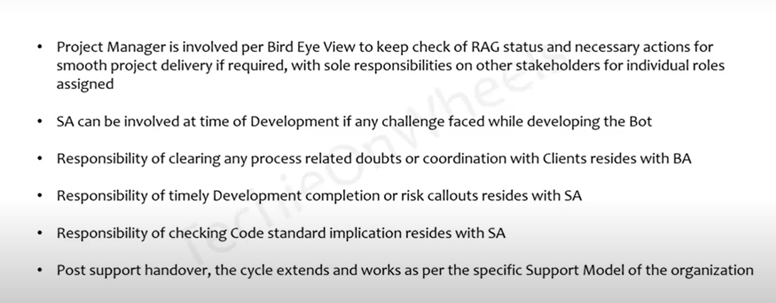

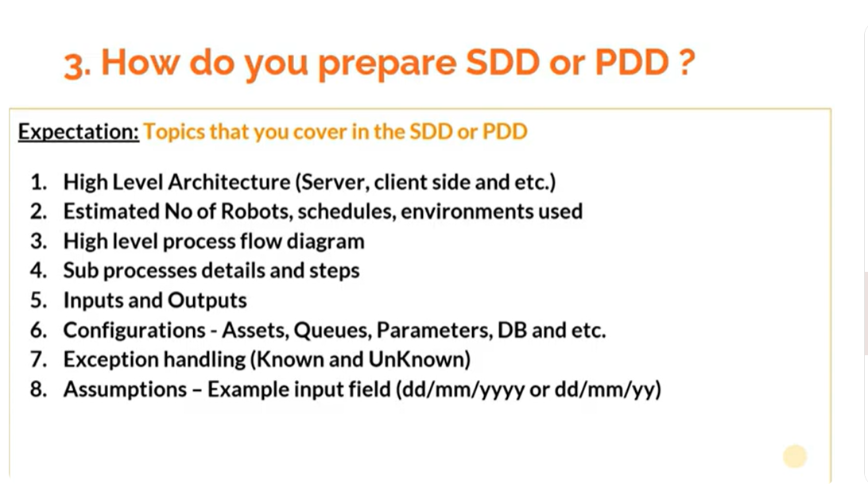

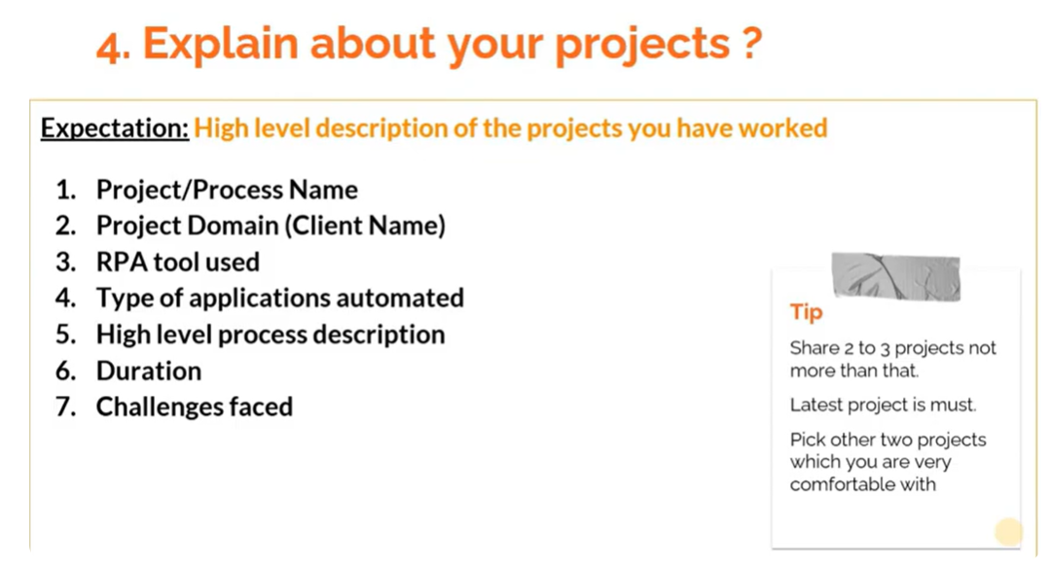

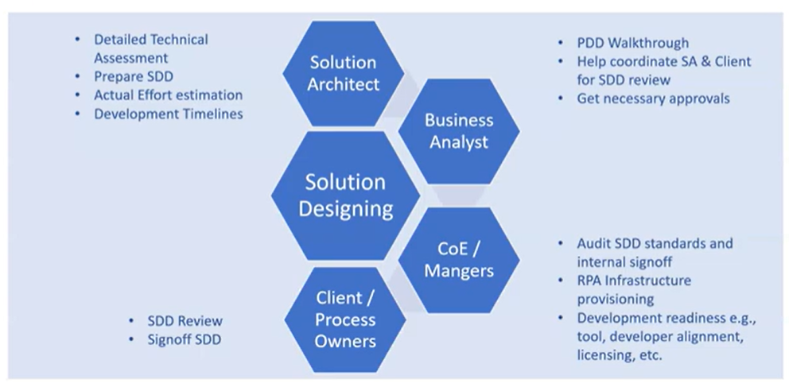

# What is RPA Solution Design Phase? What is Solution Design Document? Who all are involved ?

SDD Process:

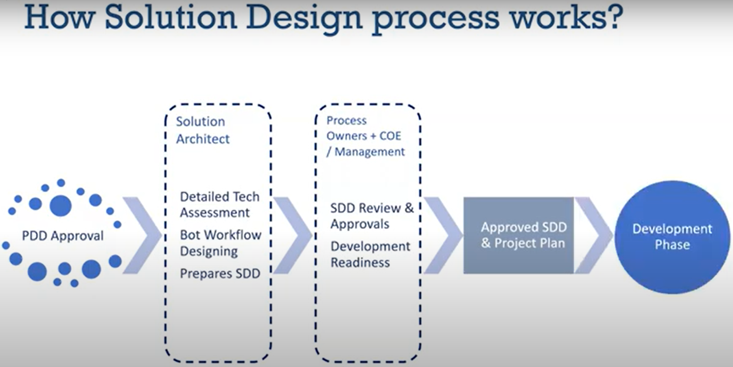

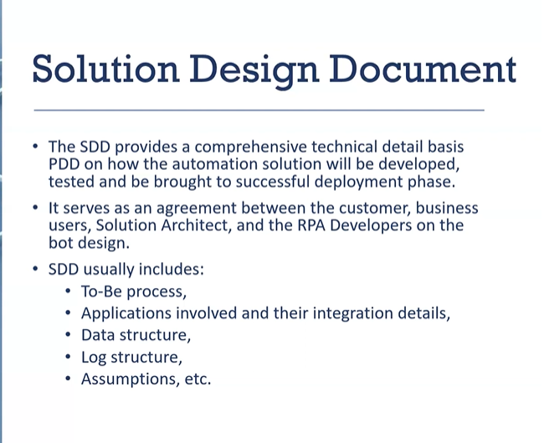

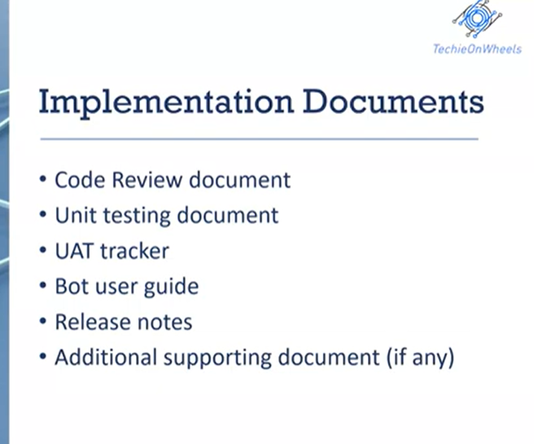

# RPA Feasibility Analysis | How to calculate process feasibility | Feasibility matrix

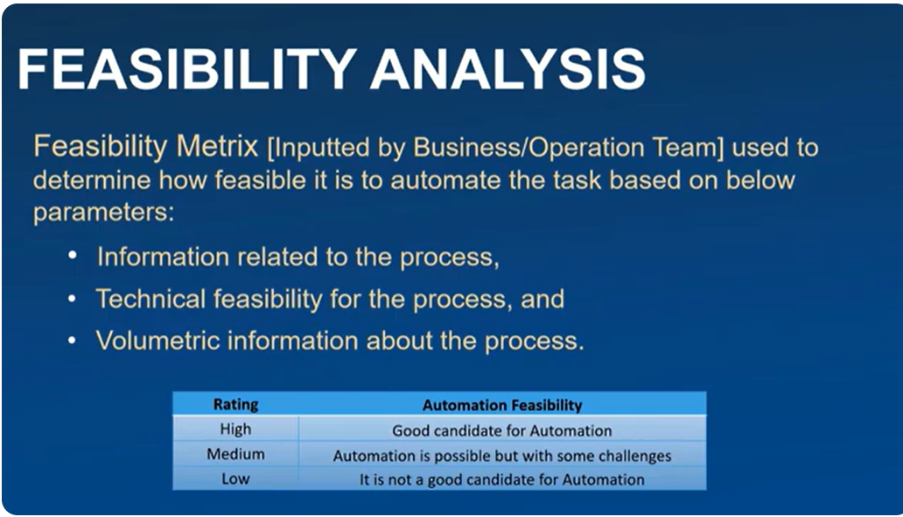

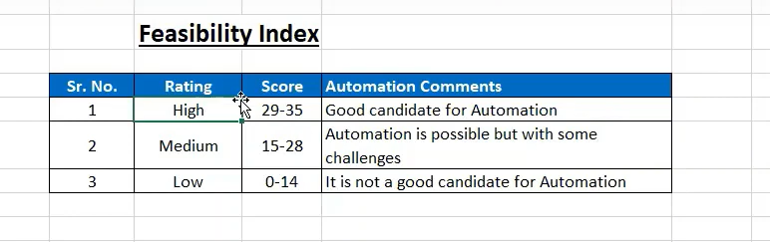

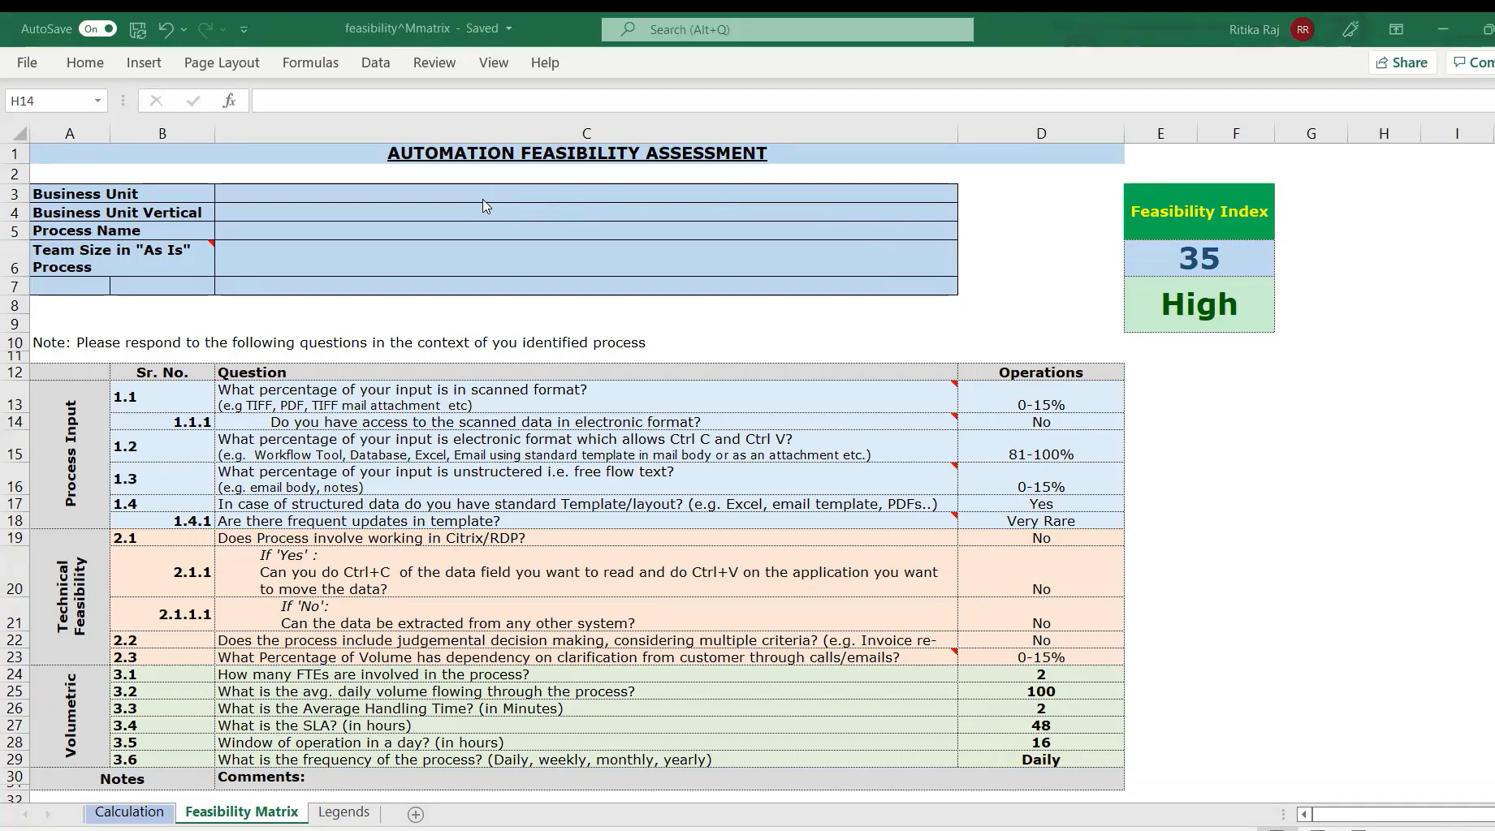

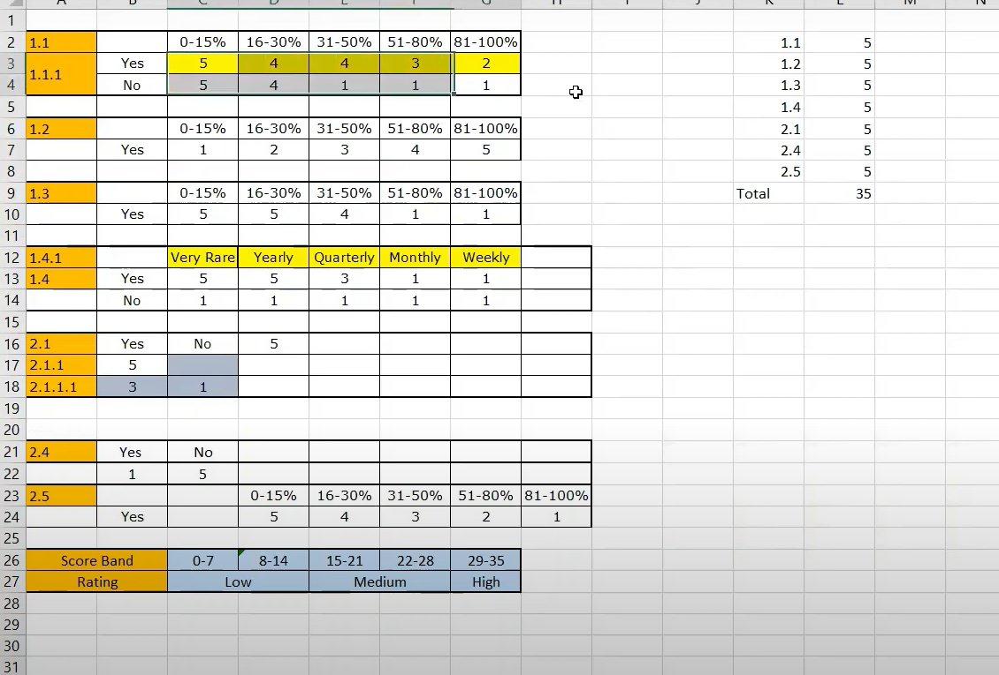

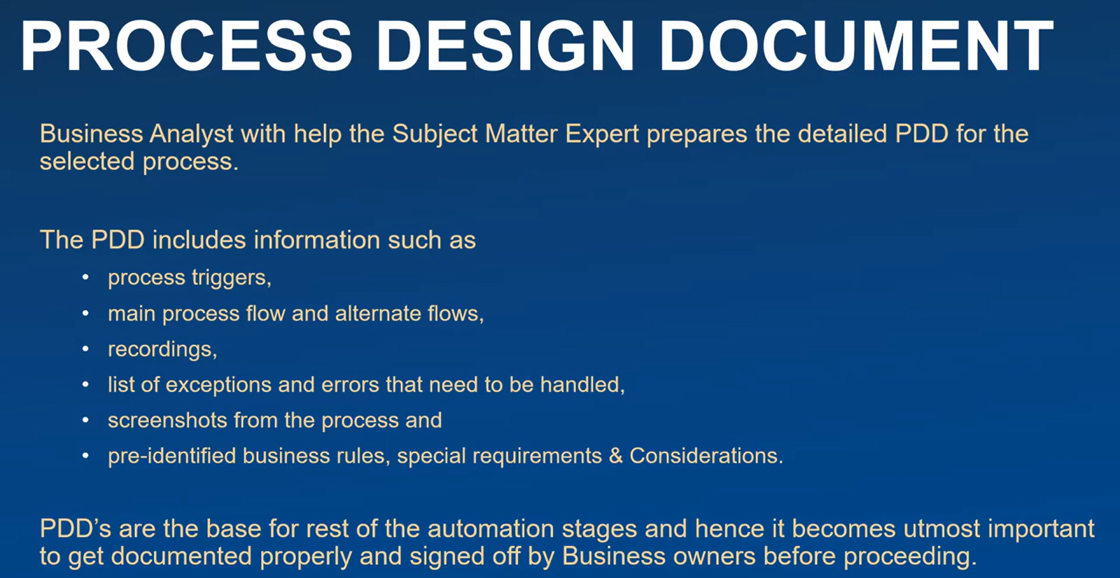

<https://www.youtube.com/watch?v=JVpL073lQik&list=PLwwgouCkMcyLbvxQGKbDIEPUTMYwegt-0&index=3>

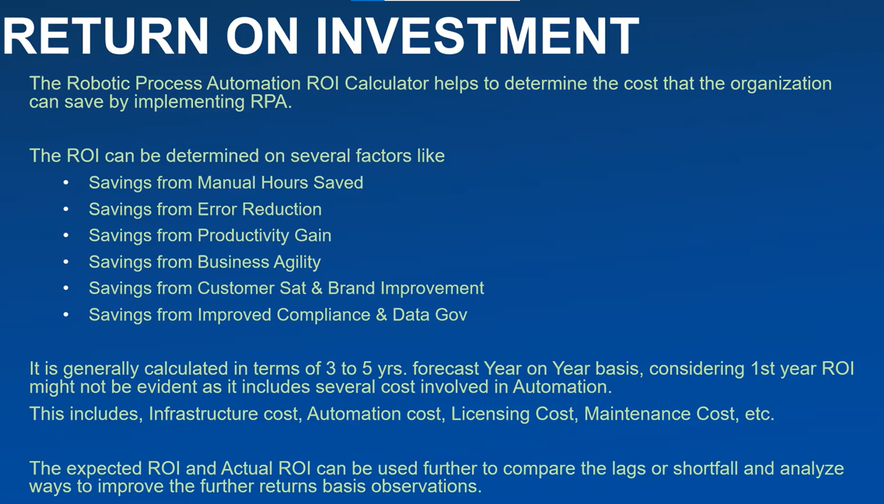

Template:

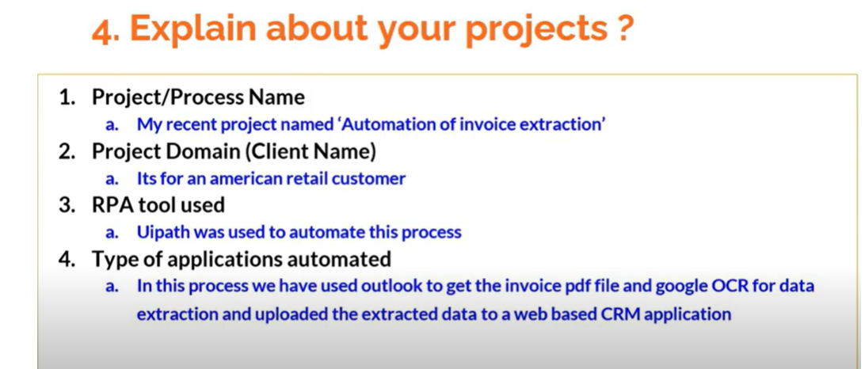

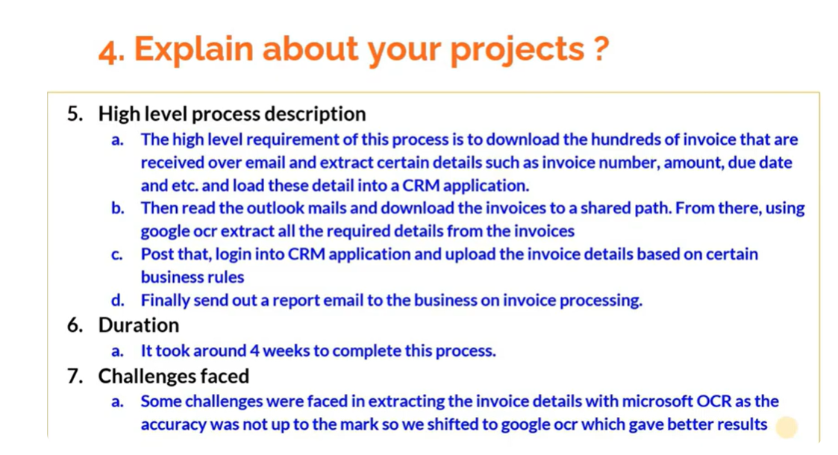

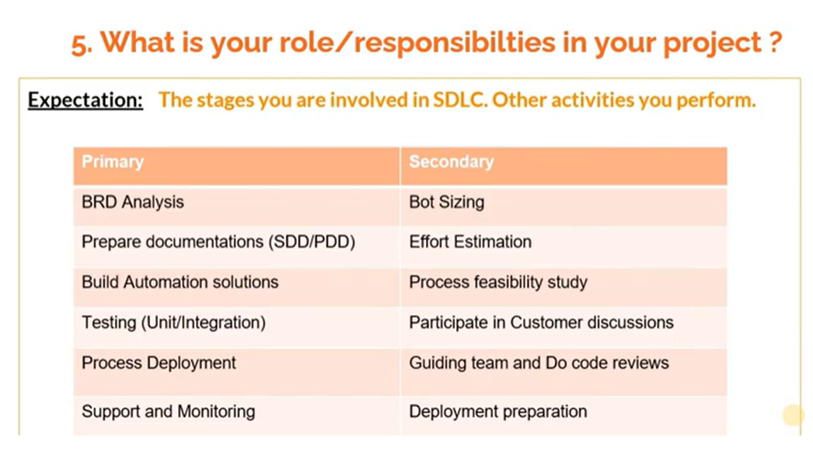

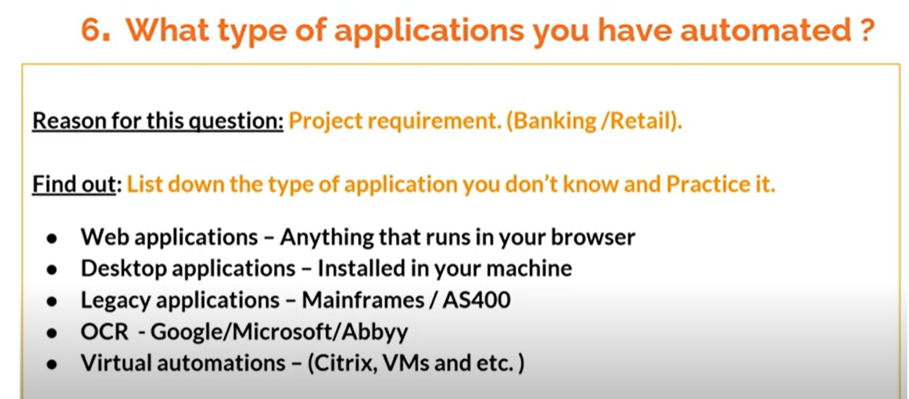

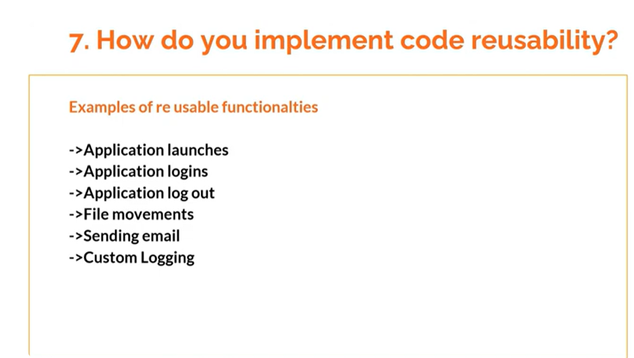

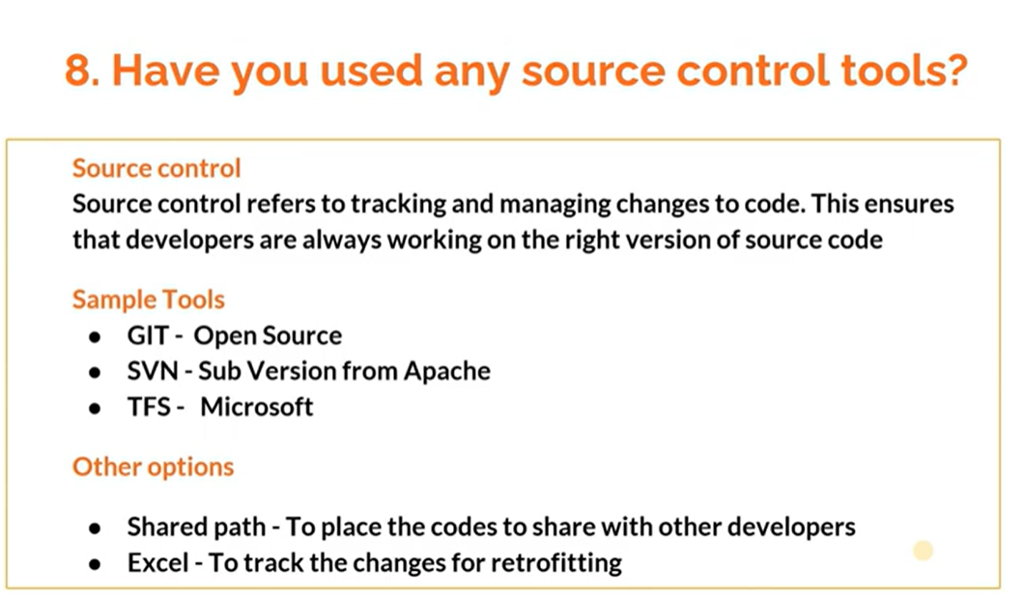

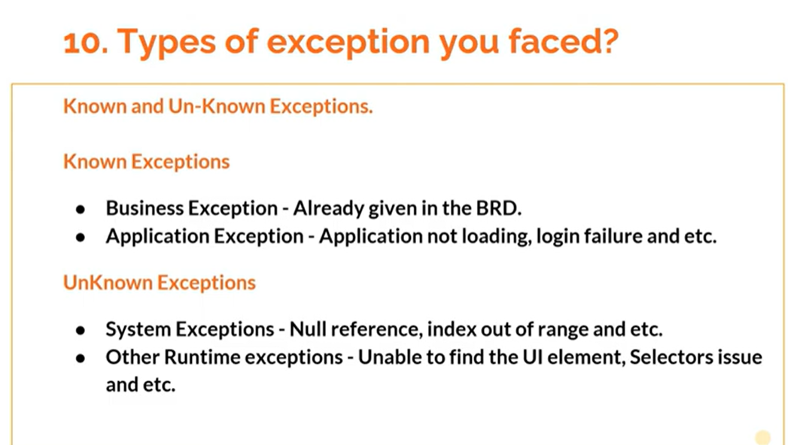

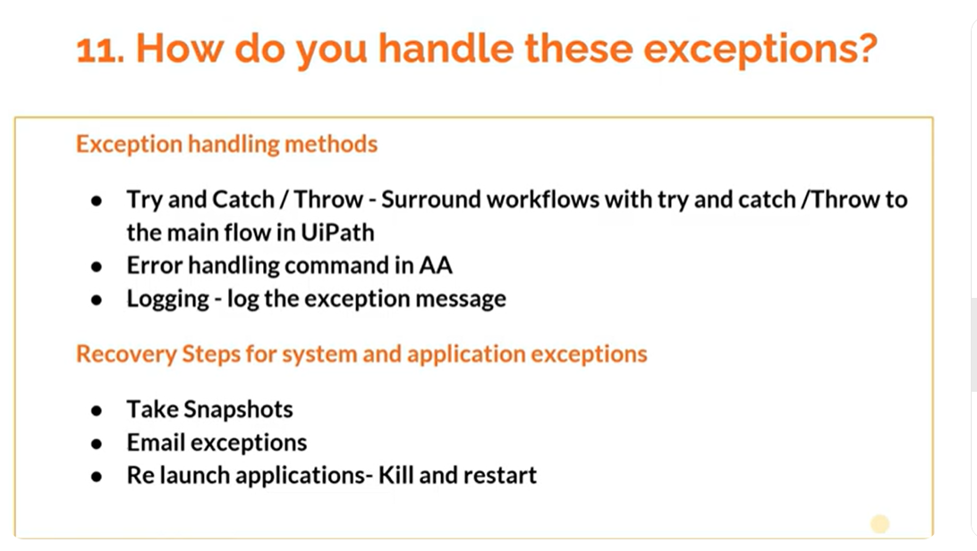

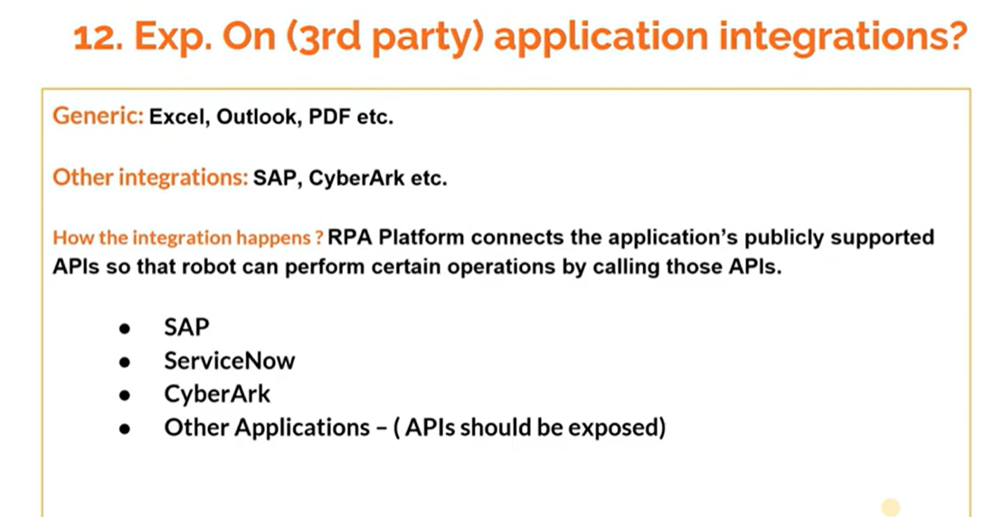

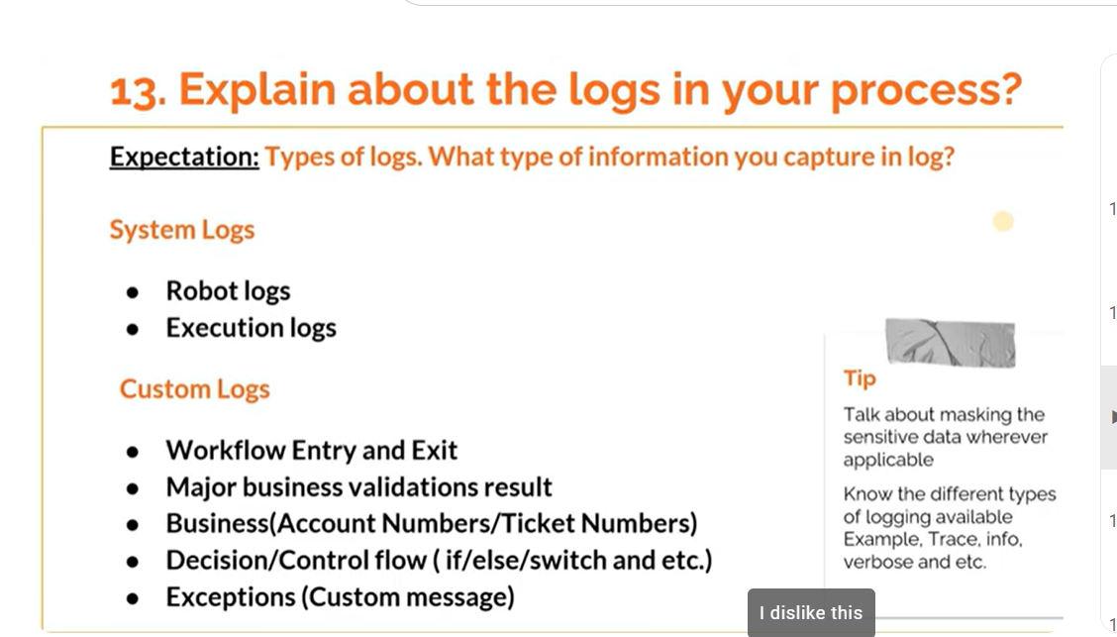

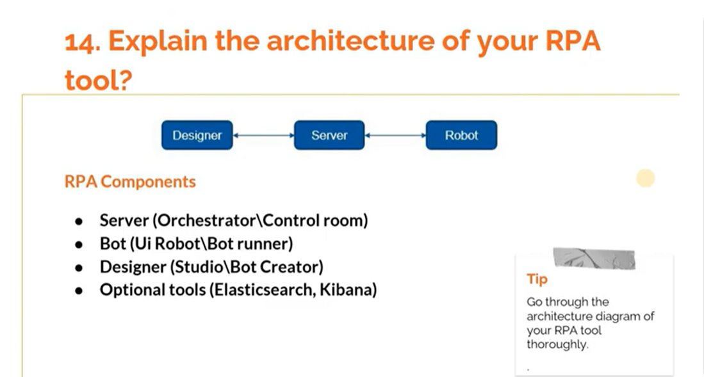

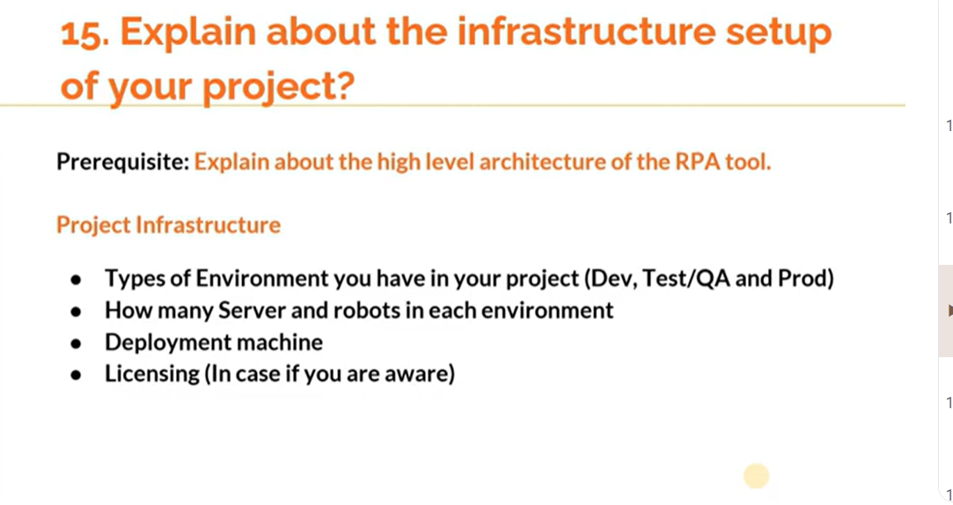

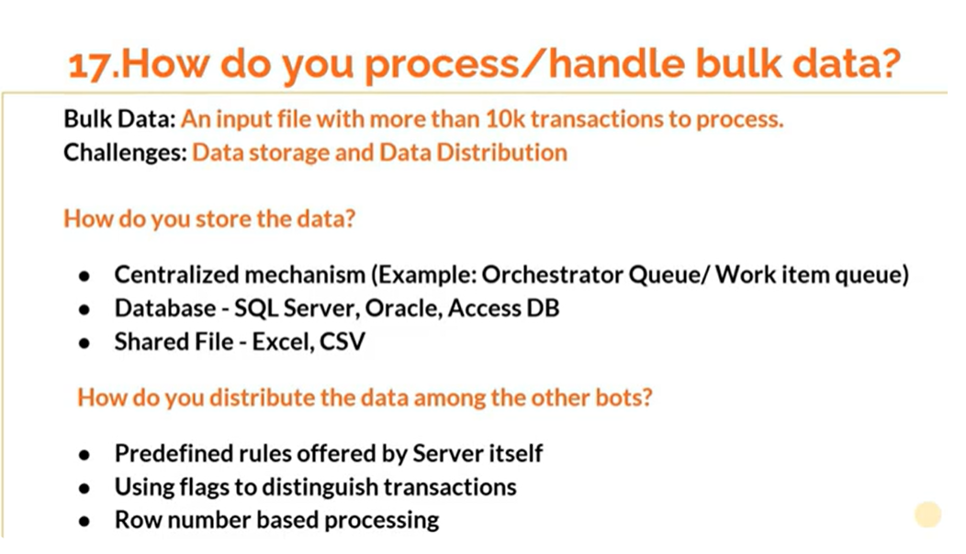

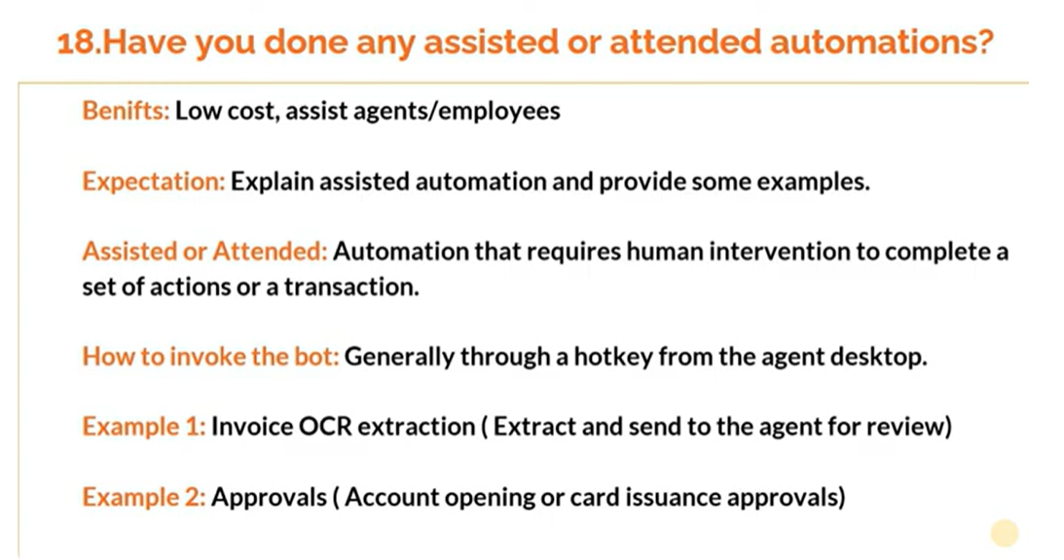

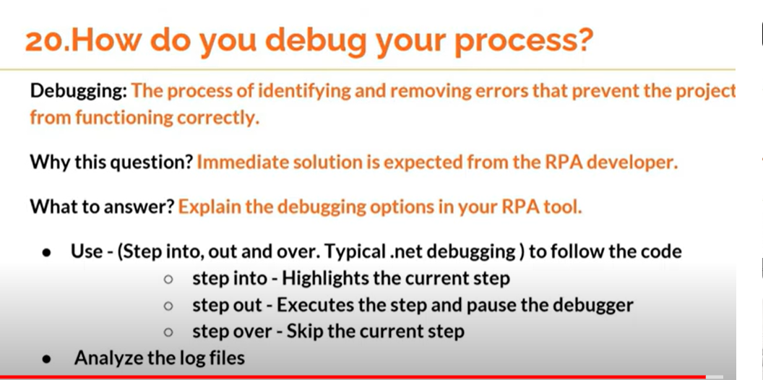

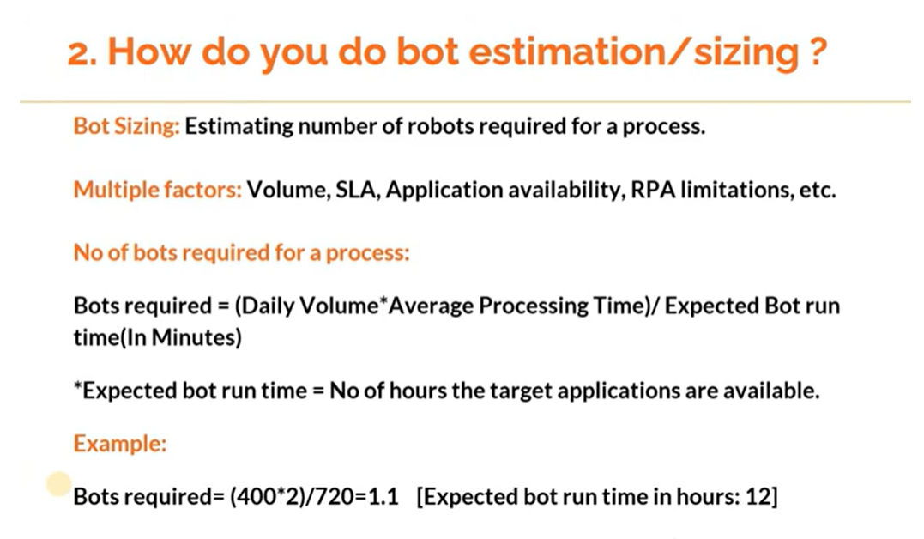

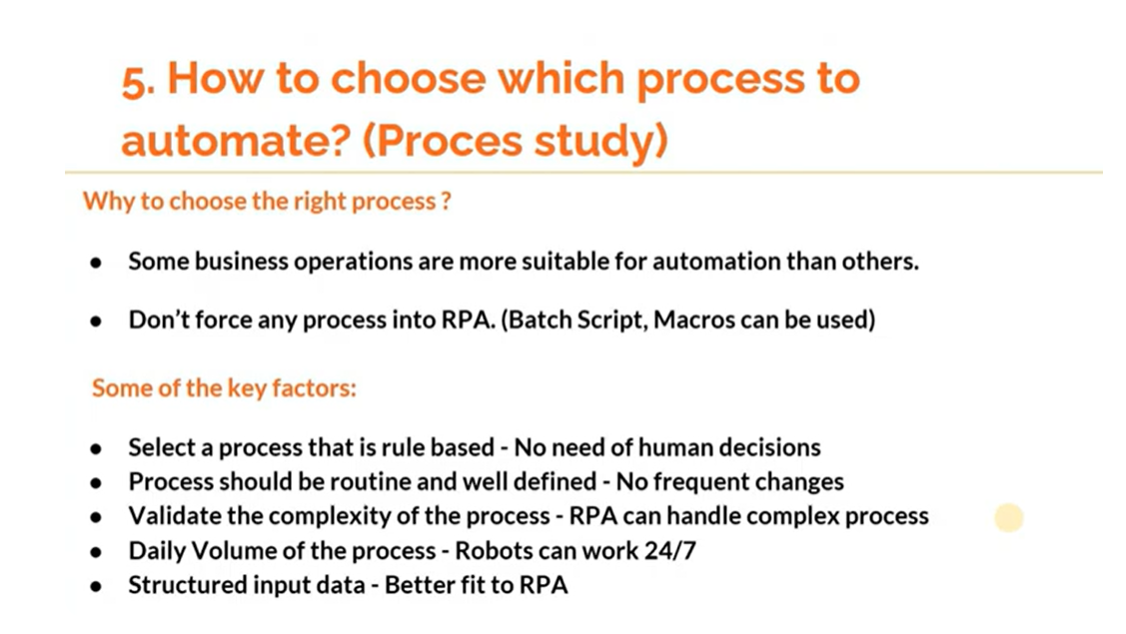

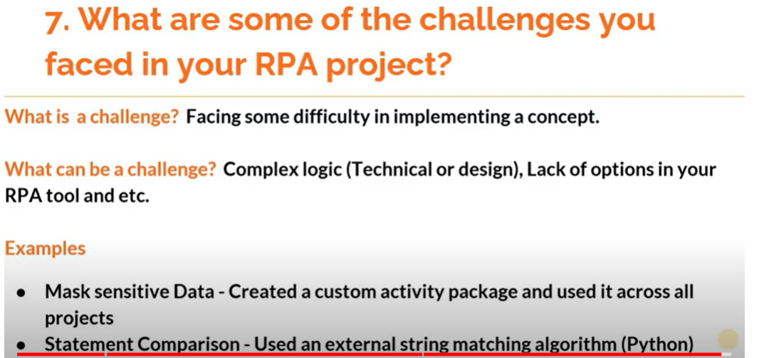

# Interview Experience -DIfficulties and challenges

How Will manage the changes in the existing Process

(after Development has been Completed)

its Come under the change Management and Change Tracker

ANS: CR-- Change Request

3 types of Change Tracker

Low ,Medium ,High

Low==> 1-3,Including Testing

Medium==> 3-5 Days

High -->5-7 days

How Will you identify particular process is automatable or not ?

the think application developed 30 Years and 40 yreas Back ,its difficult to automate and if If FTE More than 5 and 10 ,its automatiable. Full Time Employes

How Will you calculate effort and estimation for process to automate(i.e FTE Calculation)

What are the deployment methods youre following in your process?

3 Method

Pilot

Live Server 3 or 4 Working Days

Real Production Environtment

Any Changes :

1-Development Server

2.UAT Server(Staging Server

3.Control Room Server

================

Explain about Source Code management ?

Git Hup

What are Challanges or difficulty in faced while automation in your project or Application

How Implement the Risk and Disaster Management in your automation process?

<https://www.youtube.com/watch?v=raix5Msfnfo>

[https://youtu.be/ObLTMKbGwvw](https://www.youtube.com/watch?v=ObLTMKbGwvw)

[https://youtu.be/H0evuHbEqNY](https://www.youtube.com/watch?v=H0evuHbEqNY)

[https://youtu.be/out728vdRsQ](https://www.youtube.com/watch?v=out728vdRsQ)